Packet Tracer – Skills Integration Challenge

1. Topology

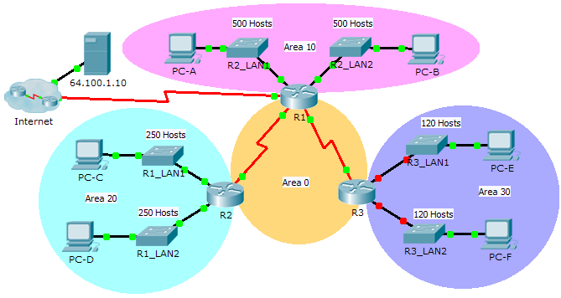

1. Addressing Table

|  |  |  |  |  |
| --- | --- | --- | --- | --- |
| Device | Interface | IP Address | Subnet Mask | Default Gateway |
| R1 | G0/0 | 172.31.25.254 | 255.255.254.0 | N/A |
| G0/1 | 172.31.27.254 | 255.255.254.0 | N/A |
| S0/0/0 | 172.31.31.249 | 255.255.255.252 | N/A |
| S0/0/1 | 172.31.31.253 | 255.255.255.252 | N/A |
| S0/1/0 | 209.165.201.2 | 255.255.255.252 | N/A |
| R2 | G0/0 | 172.31.28.254 | 255.255.255.0 | N/A |
| G0/1 | 172.31.29.254 | 255.255.255.0 | N/A |
| S0/0/0 | 172.31.31.250 | 255.255.255.252 | N/A |
| R3 | G0/0 |  |  | N/A |
| G0/1 |  |  | N/A |
| S0/0/1 | 172.31.31.254 | 255.255.255.252 | N/A |
| PC-A | NIC | 172.31.24.1 | 255.255.254.0 | 172.31.25.254 |
| PC-B | NIC | 172.31.26.1 | 255.255.254.0 | 172.31.27.254 |
| PC-C | NIC | 172.31.28.1 | 255.255.255.0 | 172.31.28.254 |
| PC-D | NIC | 172.31.29.1 | 255.255.255.0 | 172.31.29.254 |
| PC-E | NIC |  |  |  |
| PC-F | NIC |  |  |  |

1. Scenario

As network technician familiar with IPv4 addressing, routing and network security, you are now ready to apply your knowledge and skills to a network infrastructure. Your task is to finish designing the VLSM IPv4 addressing scheme, implement multi-area OSPF and secure access to the VTY lines using access control lists.

1. Requirements

* The **R3** LANs need addressing. Complete the VLSM design using the next available subnets in the remaining **172.31.30.0/23** address space.
  + - 1. Assign the first subnet for 120 hosts to **R3** LAN1.
      2. Assign the second subnet for 120 hosts to **R3** LAN2.
* Document your addressing scheme by completing the **Addressing Table**.
  1. Assign the last IP address in the subnet to the appropriate **R3** interface.
  2. Assign the first IP address in the subnet to the PC.
* Configure addressing for **R3**, **PC-E** and **PC-F**.
* Implement multiarea OSPF using 1 as the process ID.
  1. Assign the serial links to OSPF Area 0.
  2. Configure the router ID as **x.x.x.x** where **x** is the number of the router. For example, the router ID for **R1** is 1.1.1.1.
  3. Summarize the LANs in each area and advertise them using one network statement.
     + - 1. Assign the R1 LANs to OSPF Area 10.
         2. Assign the R2 LANs to OSPF Area 20.
         3. Assign the R3 LANs to OSPF Area 30.
  4. Prevent routing updates from being sent out LAN interfaces. Do not use the **default** argument.
* Implement default routing to the Internet.
  1. Configure **R1** with a directly attached default route.
  2. Advertise the default route to **R2** and **R3**.
* Configure MD5 authentication on the serial interfaces
  1. Use **1** as the key.
  2. Use **cisco123** as the key string.
* Limit VTY access to **R1**.
  1. Configure an ACL number 1.
  2. Only **PC-A** is allowed to telnet into **R1**.